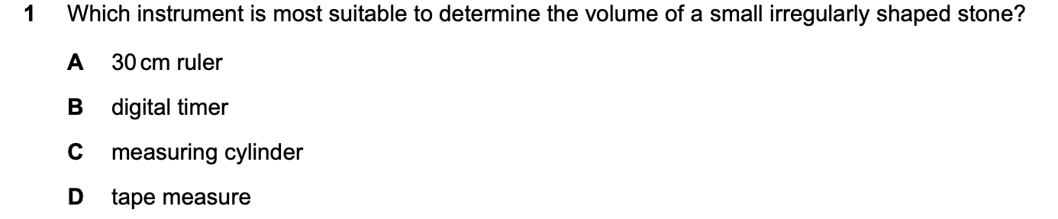
Answer_____
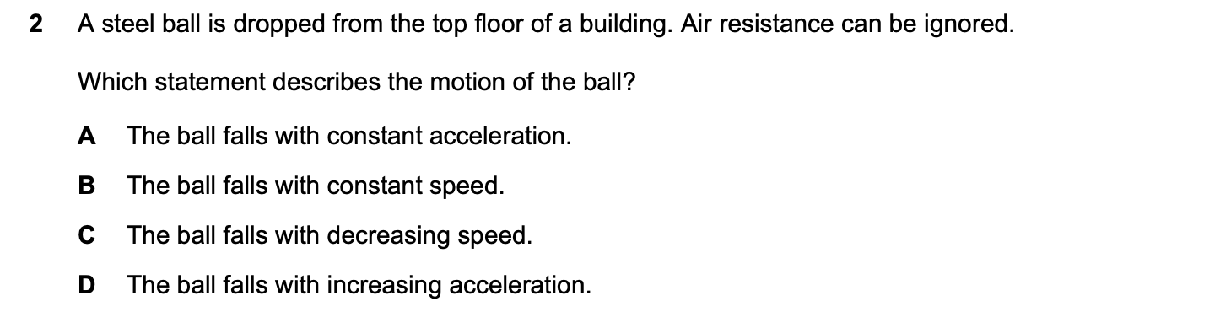
Answer_____
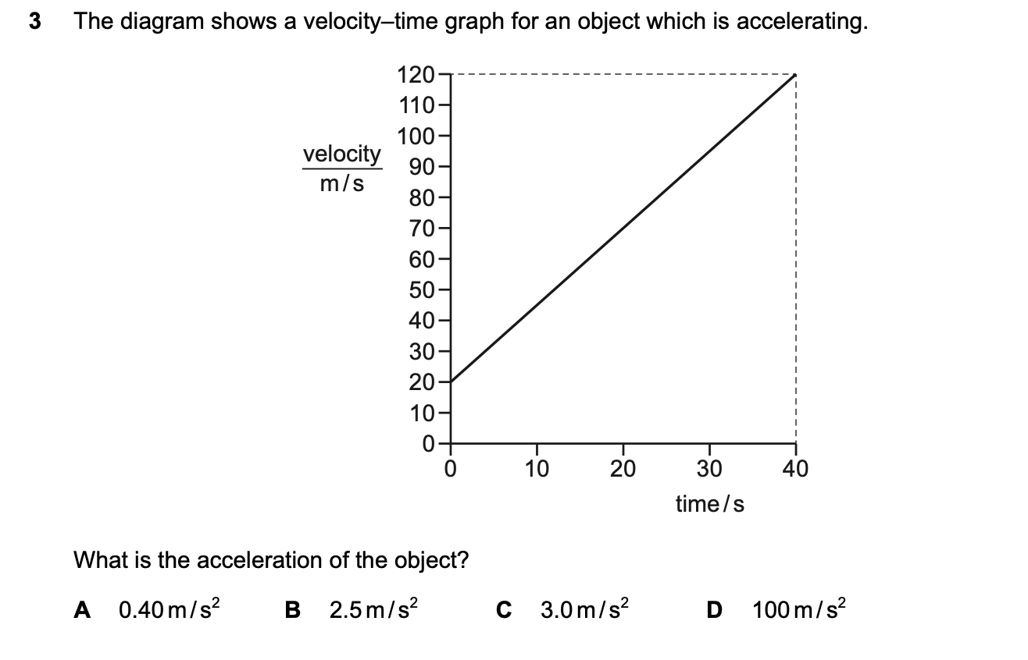
Answer_____
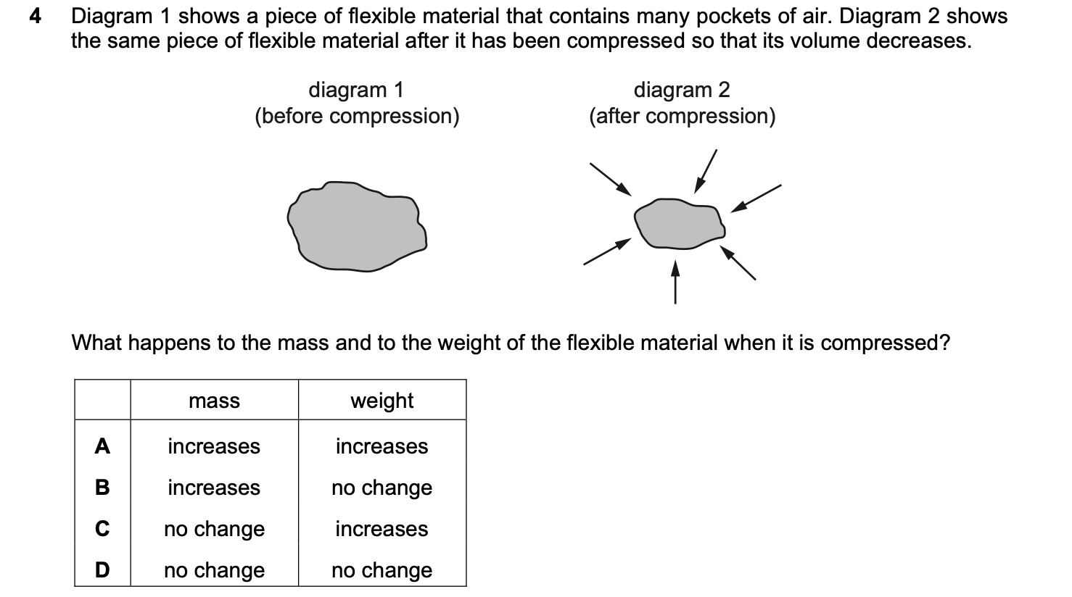
Answer_____
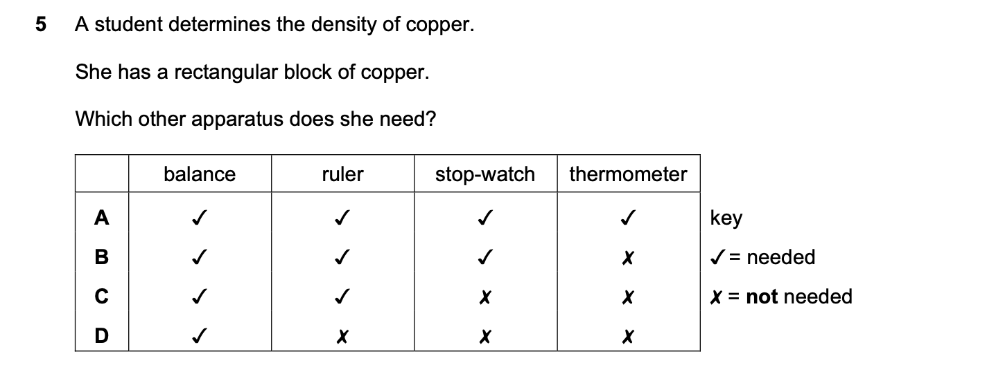
Answer_____
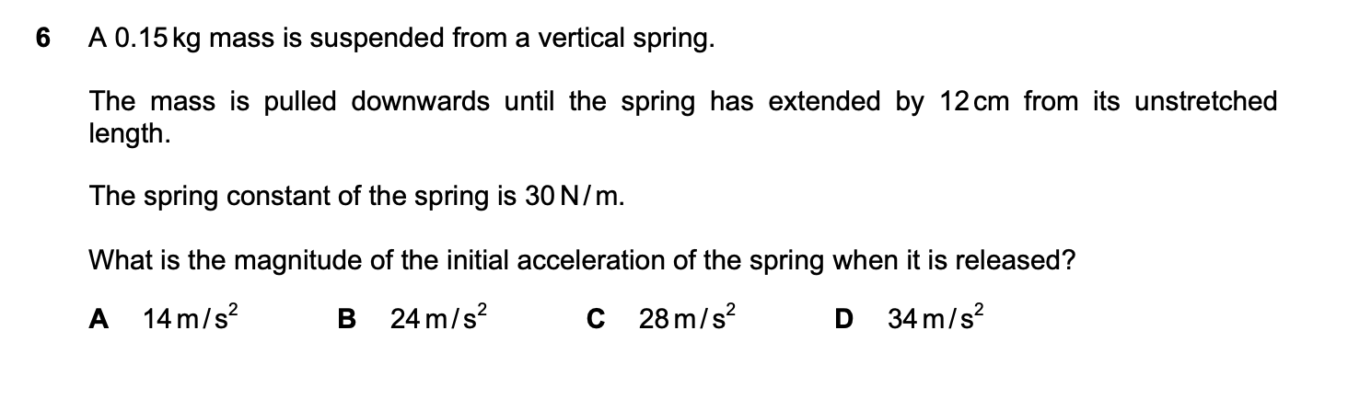
Answer_____
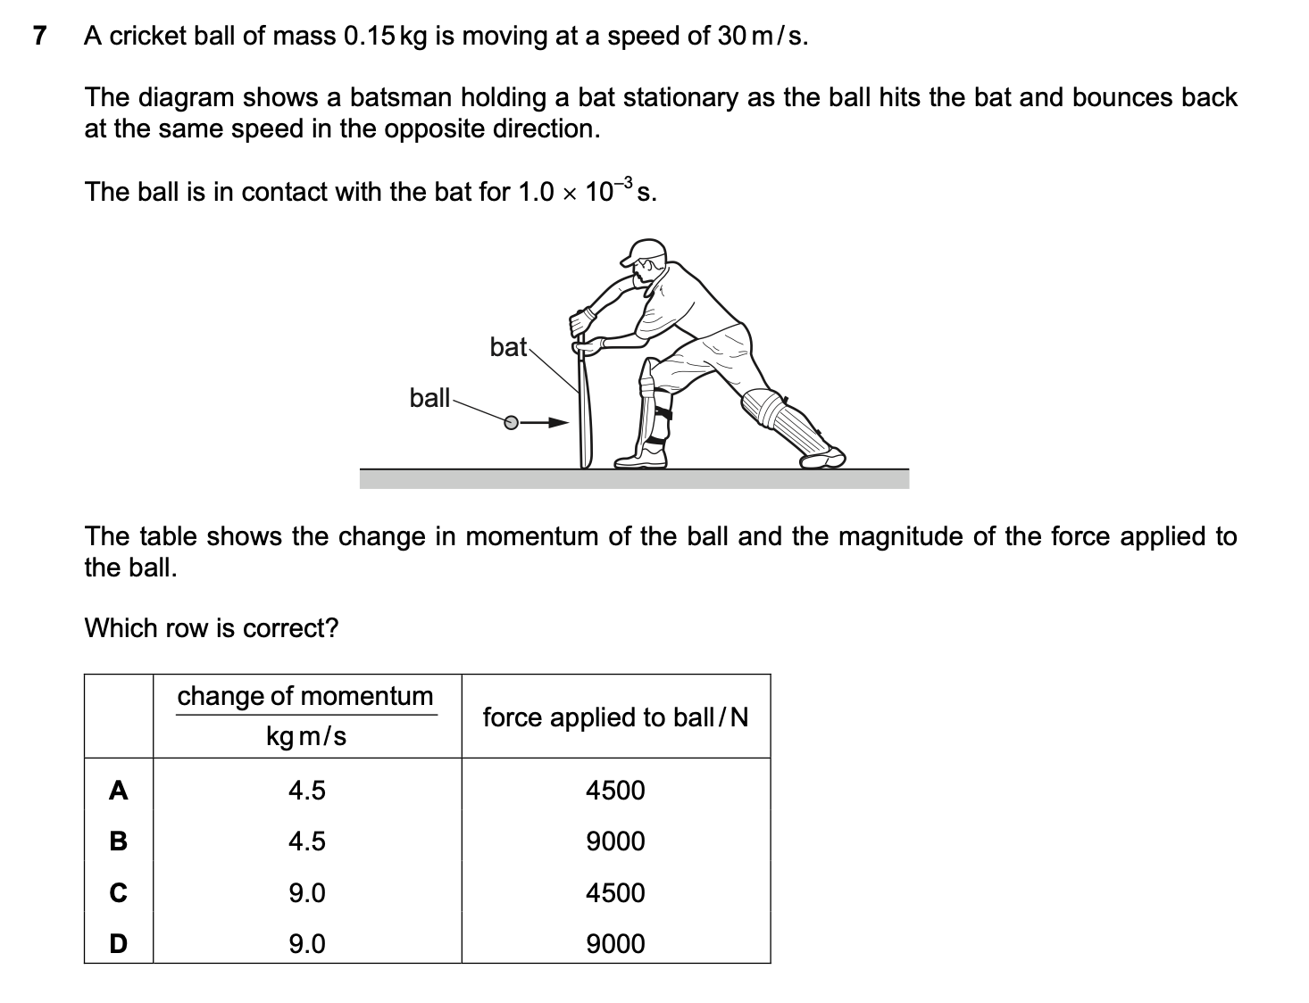
Answer_____
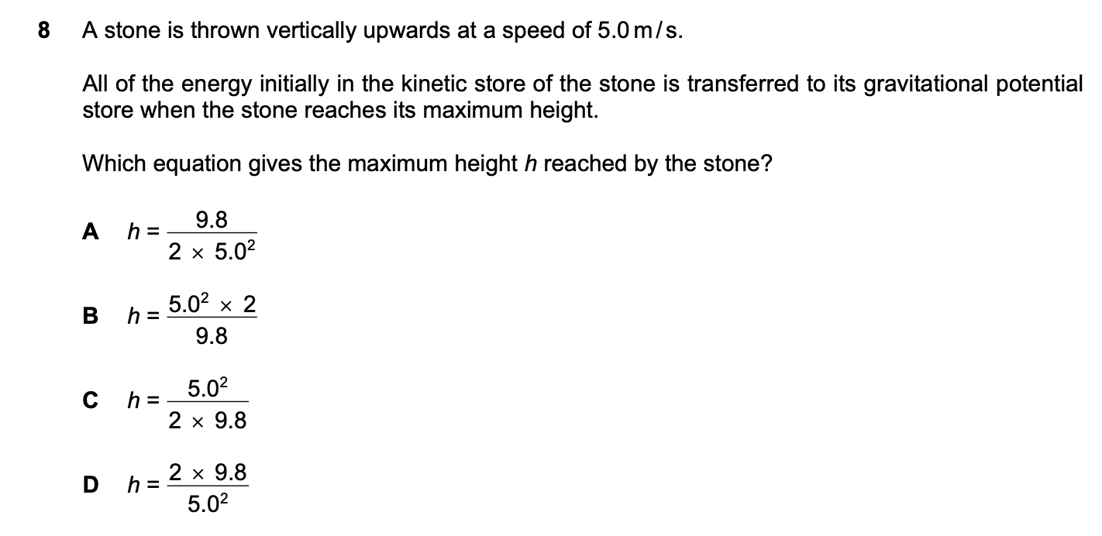
Answer_____
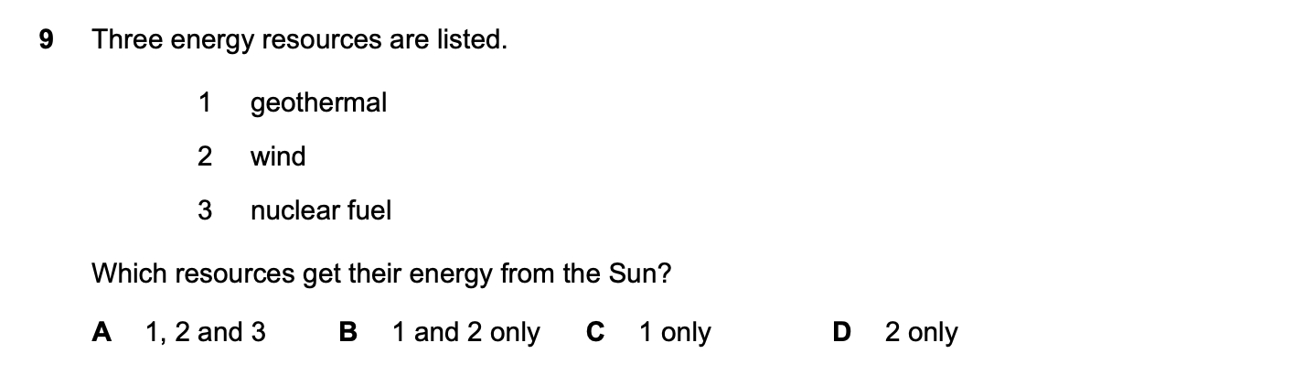
Answer_____

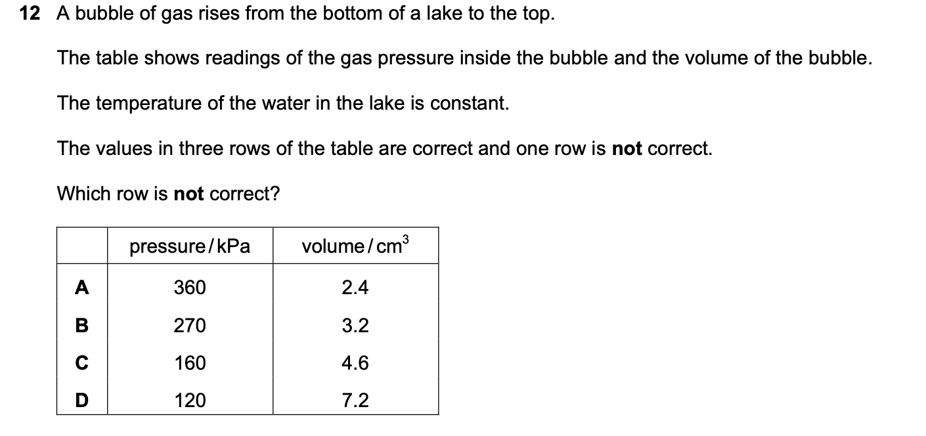
Answer_____

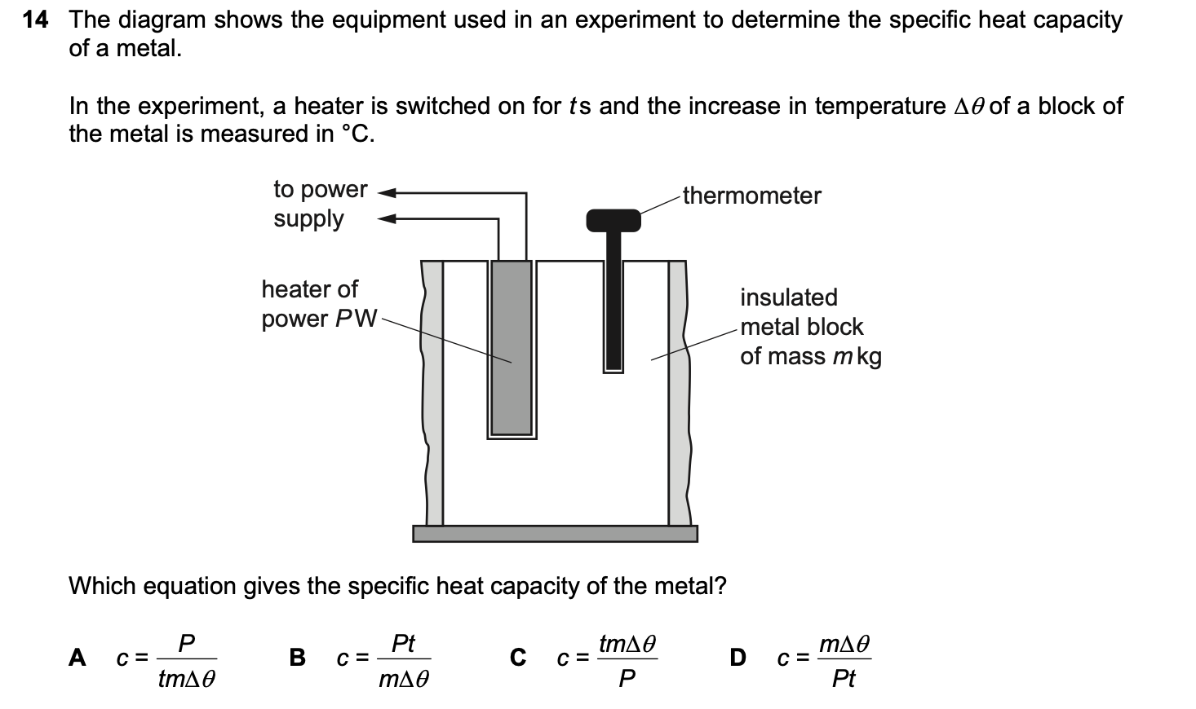
Answer_____
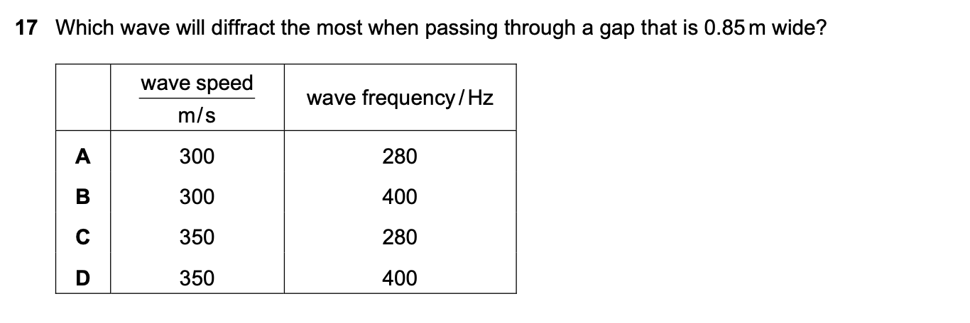
Answer_____
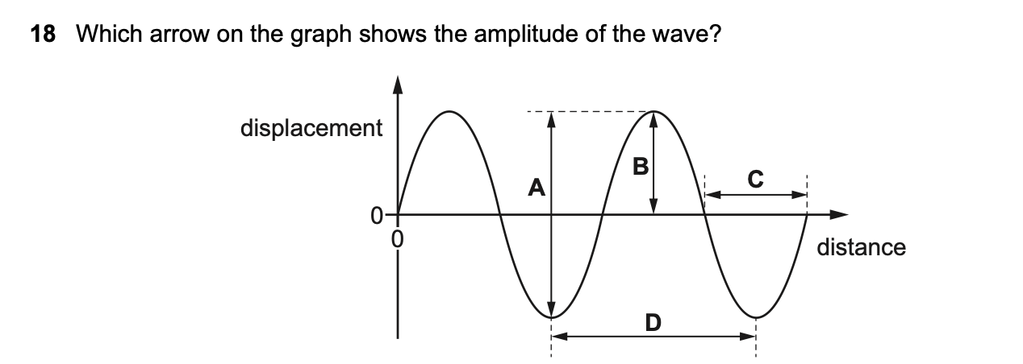
Answer_____
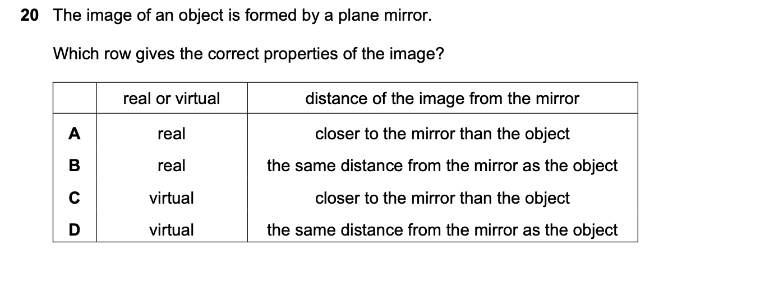
Answer_____
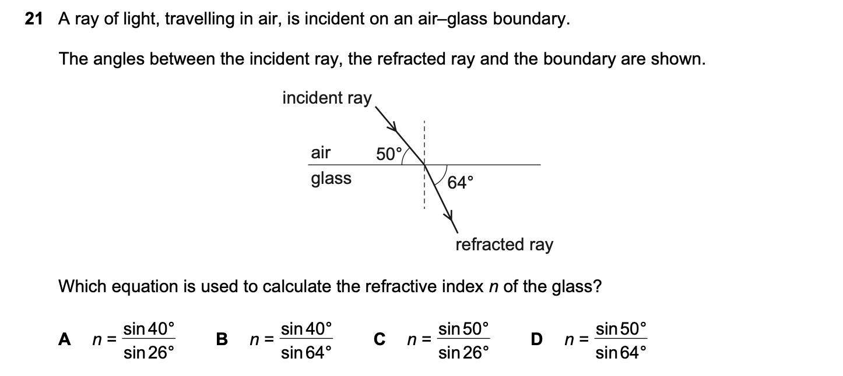
Answer_____
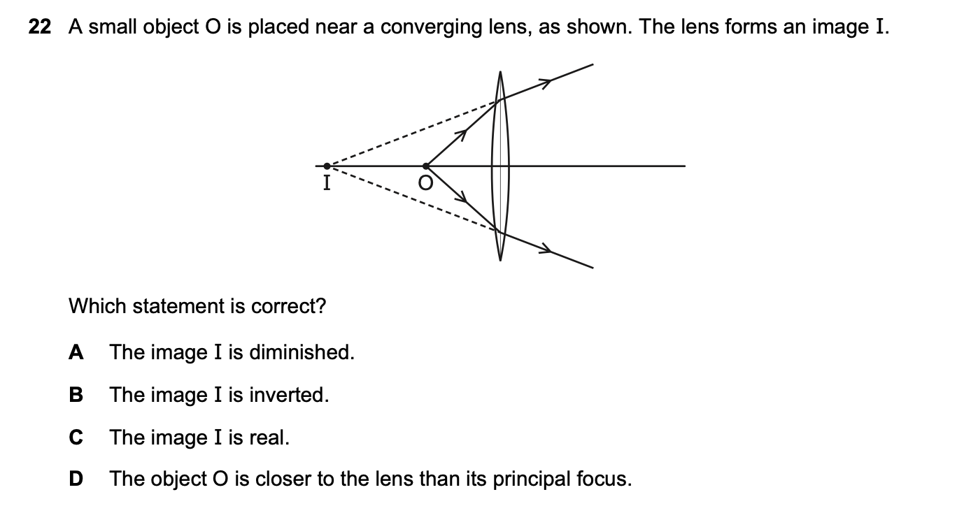
Answer_____
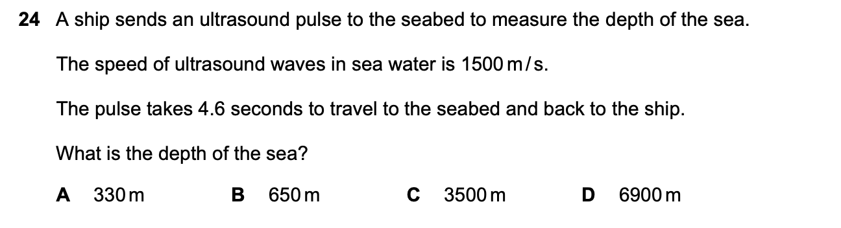
Answer_____
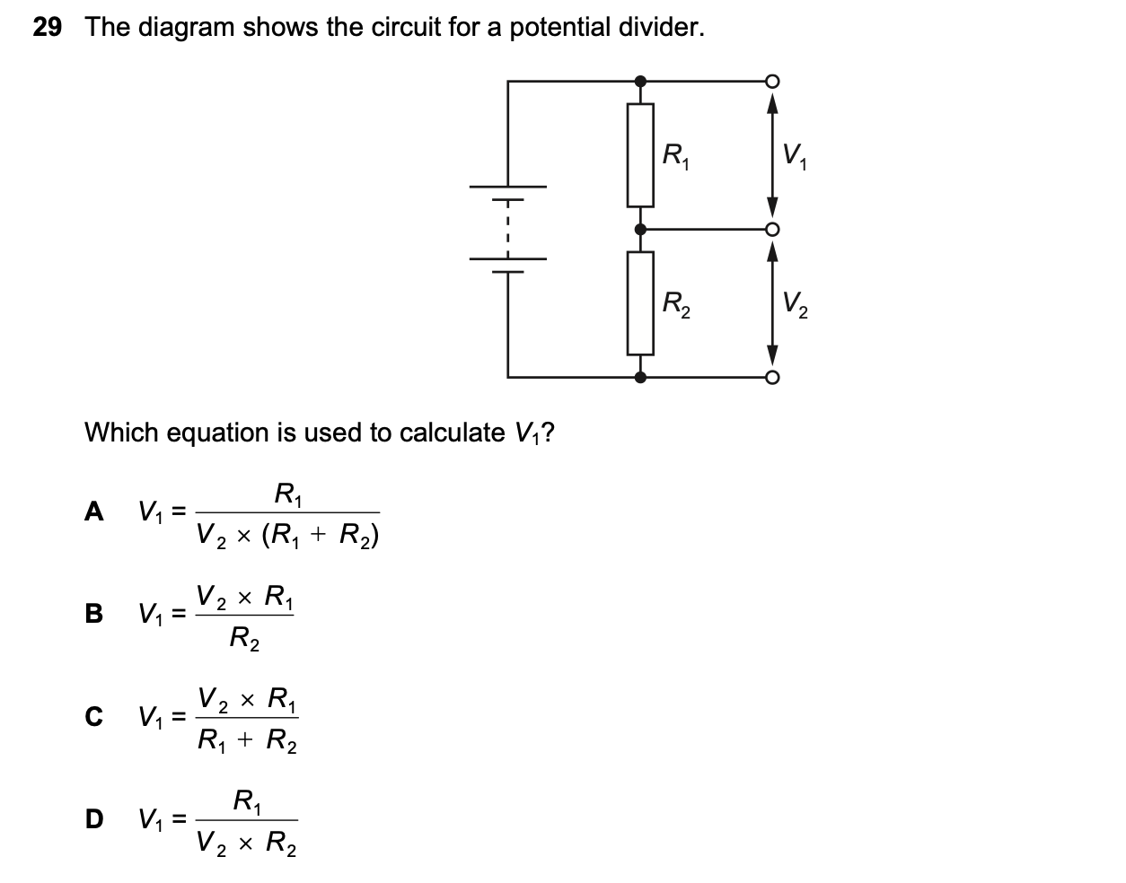
Answer_____
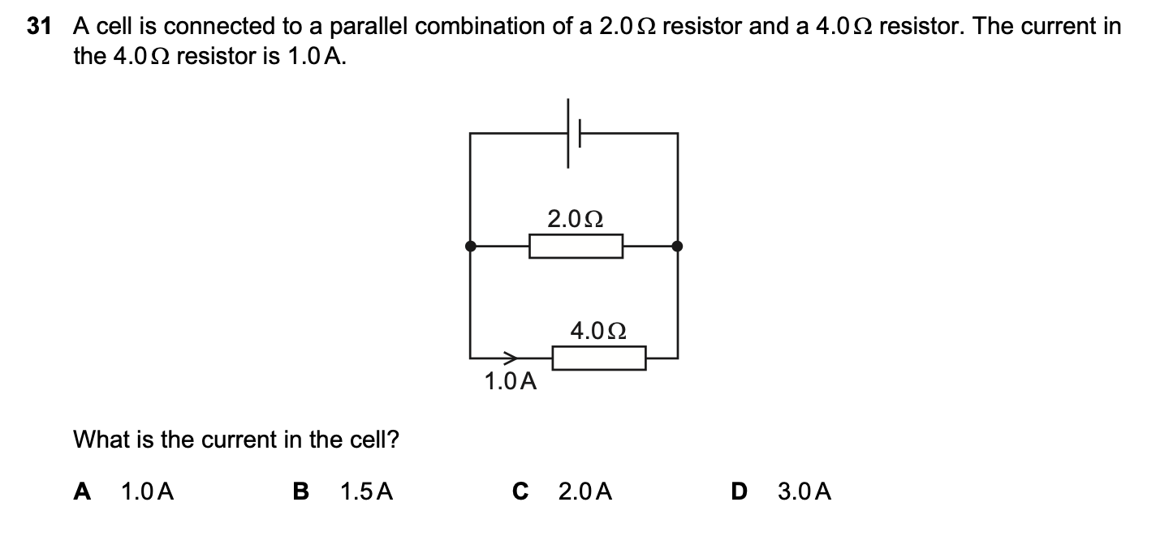
Answer_____
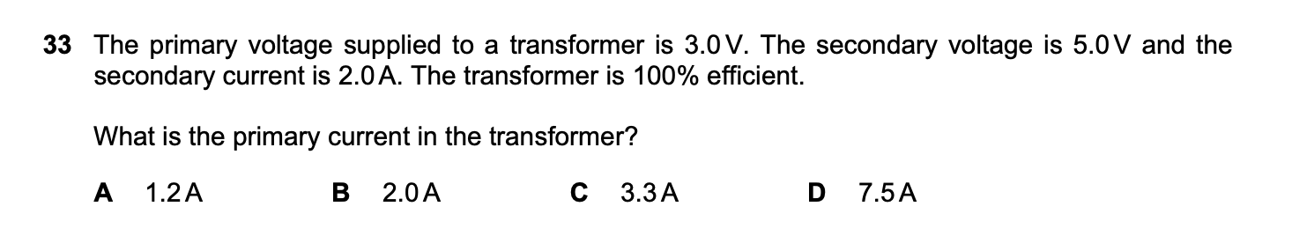
Answer_____
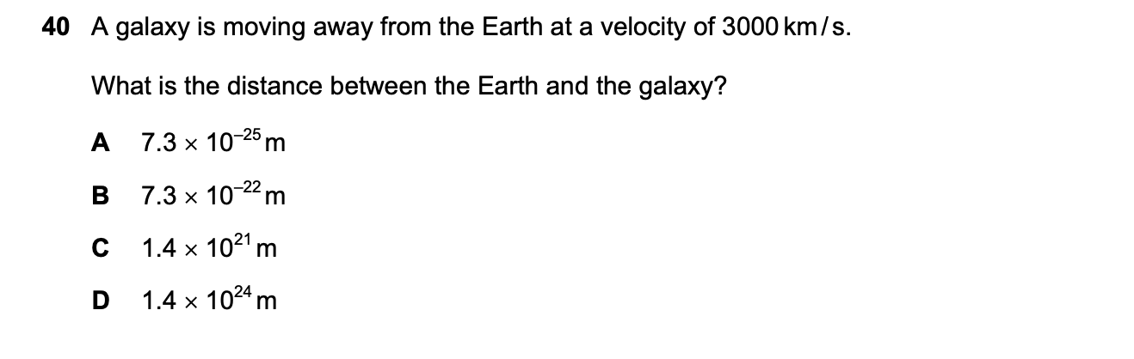
Answer_____
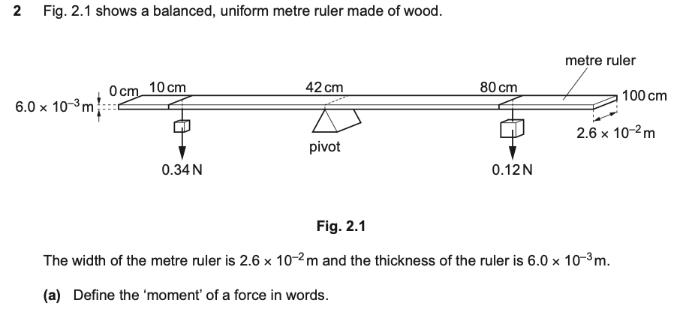
Answer________________________________________________________________________________________________________________________________________(1)
Answer_________________________________________________________________________________________________________________________________________(3)

Answer________________________________________________________________________________________________________________________________________(2)

Answer________________________________________________________________________________________________________________________________________(1)
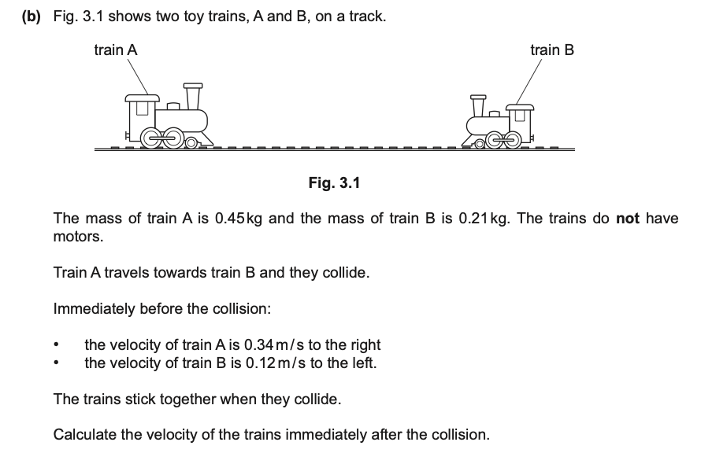
Answer____________________________________________________________________________________________________________________________________________________________________________________________________________________________________________________________________________________________(4)

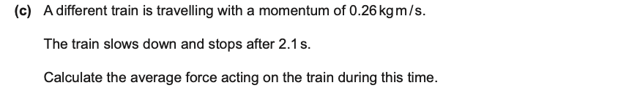
Answer____________________________________________________________________________________________________________________________________________________________________________________________________________________________________________________________________________________________(2)
4.
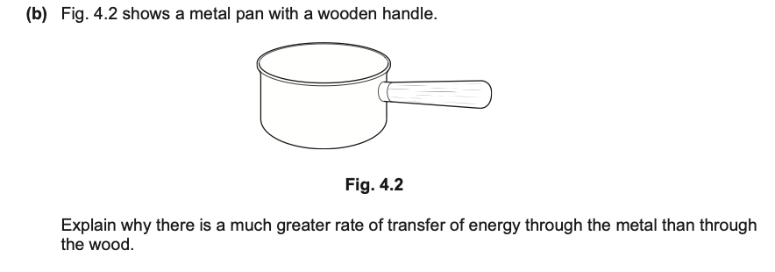
Answer____________________________________________________________________________________________________________________________________________________________________________________________________________________________________________________________________________________________(3)

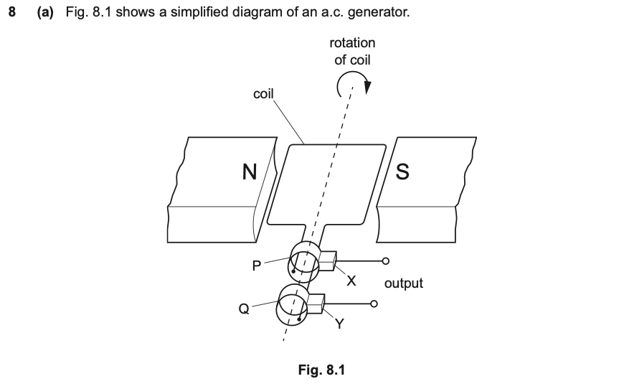
P and Q___________________________________________________________________
_________________________________________________________________________
X and Y___________________________________________________________________
_____________________________________________________________________(2)
Answer_________________________________________________________________________________________________________________________________________(1)

Answer_________________________________________________________________________________________________________________________________________(1)
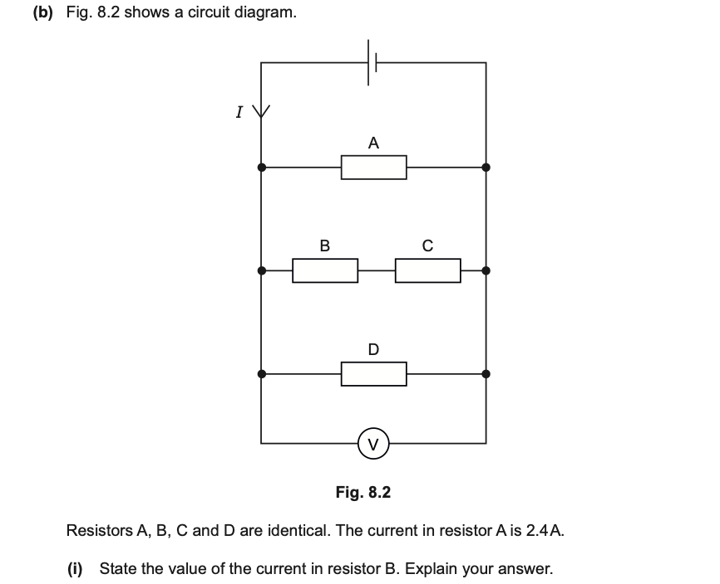
Answer_________________________________________________________________________________________________________________________________________(2)
Answer_________________________________________________________________________________________________________________________________________(1)


Answer_________________________________________________________________________________________________________________________________________(2)

10.
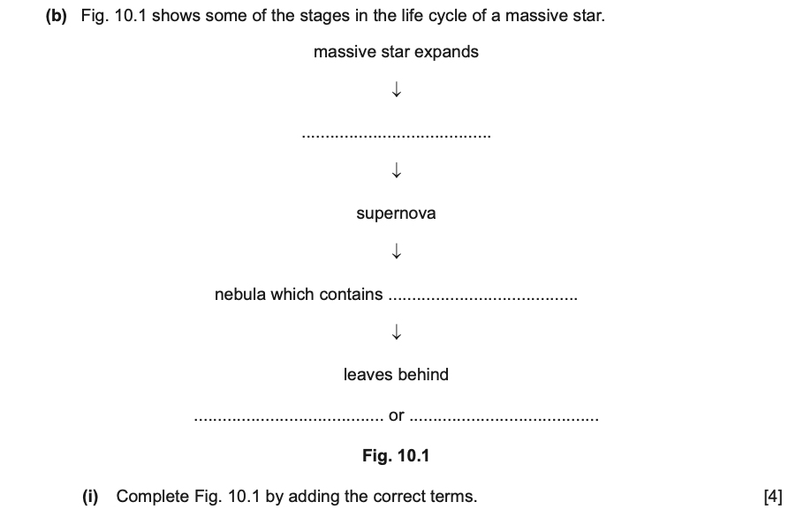
Answer_____________________________________________________________________________________________________________________________________________________________________________________________________________________
Answer_________________________________________________________________________________________________________________________________________(1)

